

CSE326.3

**Assignment 2**

**Date of Submission: 18-03-2018**

**Submitted By:**

**Name: M. Alimuzzaman  
ID: 1320327042**

**Submitted To:**

**Dr. Md. Ezharul Islam**

**Transition Diagrams**

1. **Transition diagram for recognizing identifiers and keywords:**

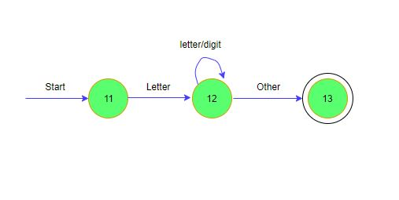

1. **Transition diagram for recognizing white space:**

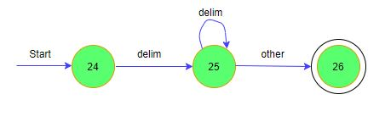

1. **Transition diagram for recognizing numbers:**

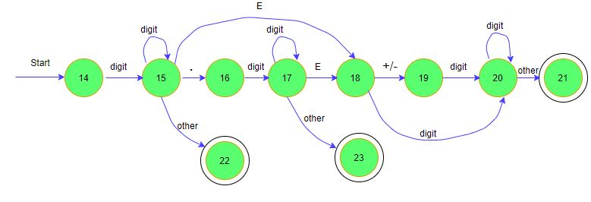

1. **Transition diagram for recognizing operators:**

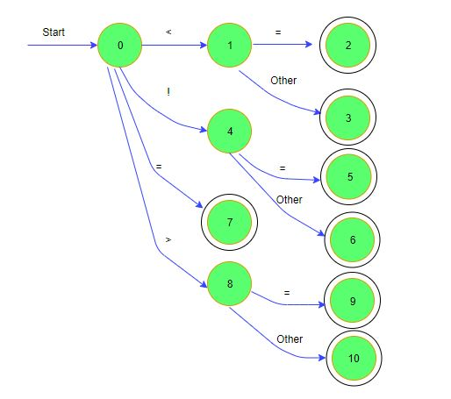

1. **Transition diagram for recognizing preprocessor command:**

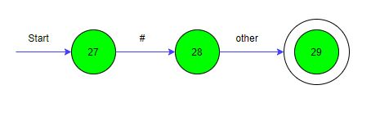

**Source Code**

#include<stdio.h>

#include<stdlib.h>

#include<string.h>

#include<ctype.h>

#include <stdbool.h>

bool isDelim(char ch)

{

if (ch == ' ' || ch == '+' || ch == '-' || ch == '*' ||

ch == '/' || ch == ',' || ch == ';' || ch == '>' ||

ch == '<' || ch == '=' || ch == '(' || ch == ')' ||

ch == '[' || ch == ']' || ch == '{' || ch == '}')

return (true);

return (false);

}

bool validIdentifier(char* str)

{

if (str[0] == '0' || str[0] == '1' || str[0] == '2' ||

str[0] == '3' || str[0] == '4' || str[0] == '5' ||

str[0] == '6' || str[0] == '7' || str[0] == '8' ||

str[0] == '9' || str[0] == '.'|| isDelim(str[0]) == true)

return (false);

return (true);

}

bool isKeyword(char* str)

{

if (!strcmp(str, "if") || !strcmp(str, "else") ||

!strcmp(str, "while") || !strcmp(str, "do") ||

!strcmp(str, "break") ||

!strcmp(str, "continue") || !strcmp(str, "int")

|| !strcmp(str, "double") || !strcmp(str, "float")

|| !strcmp(str, "return") || !strcmp(str, "char")

|| !strcmp(str, "case") || !strcmp(str, "char")

|| !strcmp(str, "sizeof") || !strcmp(str, "long")

|| !strcmp(str, "short") || !strcmp(str, "typedef")

|| !strcmp(str, "switch") || !strcmp(str, "unsigned")

|| !strcmp(str, "void") || !strcmp(str, "static")

|| !strcmp(str, "struct") || !strcmp(str, "goto"))

return (true);

return (false);

}

bool isInteger(char* str)

{

int i, len = strlen(str);

if (len == 0)

return (false);

for (i = 0; i < len; i++) {

if (str[i] != '0' && str[i] != '1' && str[i] != '2'

&& str[i] != '3' && str[i] != '4' && str[i] != '5'

&& str[i] != '6' && str[i] != '7' && str[i] != '8'

&& str[i] != '9' || (str[i] == '-' && i > 0))

return (false);

}

return (true);

}

bool isRealNumber(char* str)

{

int i, len = strlen(str);

bool hasDecimal = false;

if (len == 0)

return (false);

for (i = 0; i < len; i++) {

if (str[i] != '0' && str[i] != '1' && str[i] != '2'

&& str[i] != '3' && str[i] != '4' && str[i] != '5'

&& str[i] != '6' && str[i] != '7' && str[i] != '8'

&& str[i] != '9' && str[i] != '.' ||

(str[i] == '-' && i > 0))

return (false);

if (str[i] == '.')

hasDecimal = true;

}

return (hasDecimal);

}

int main(){

char ch, Buffer[10], opps[] = "+-*/%=<>";

FILE *fp;

int i,j=0;

fp = fopen("input.c","r");

if(fp == NULL){

printf("error opening the file\n");

exit(0);

}

while((ch = fgetc(fp)) != EOF){

for(i = 0; i < 8; ++i){

if(ch == opps[i])

printf("Token Found!\t'%c'\t is an operator\n", ch);

}

if(isalnum(ch)){

Buffer[j++] = ch;

}

else if((ch == ' ' || ch == '\n') && (j != 0)){

Buffer[j] = '\0';

j = 0;

if(isKeyword(Buffer) == true)

printf("Token Found!\t'%s'\tis a keyword\n", Buffer);

else if(isInteger(Buffer)==true)

printf("Token Found!\t'%s'\tis an integer\n", Buffer);

else if (isRealNumber(Buffer) == true)

printf("Token Found!\t'%s'\tis a real number\n", Buffer);

else if (validIdentifier(Buffer) == true)

printf("Token Found!\t'%s'\tis a valid identifier\n", Buffer);

}

else if(ch=='#'){

printf("Token Found!\t '%c' \t is a preprocessor command\n",ch);

}

}

fclose(fp);

return 0;

}

Sample Input

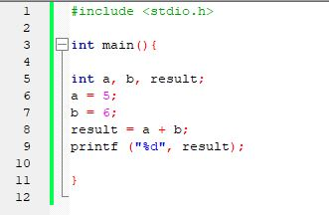

Sample Output

